Defect Detection System

Project report in partial fulfillment of the requirement for the award of the degree of
Bachelor of Technology
In
CST

Submitted By

M. Kalkita Enrollment No. 12023002022117
Oheli Das Enrollment No. 12023002022122
Ahana Bandhu Enrollment No. 12023002022120
Puspendu Sekhar Das Enrollment No. 12023002022220
Mayukh Ghosh Enrollment No. 12023002022242

Under the guidance of
Prof. Pradipta Sarkar

Department of Computer Science and Technology & Computer Science and Information Technology (CST & CSIT)


UNIVERSITY OF ENGINEERING & MANAGEMENT, KOLKATA
University Area, Plot No. III – B/5, New Town, Action Area – III, Kolkata – 700160.
CERTIFICATE

This is to certify that the project titled Defect Detection System submitted by M. Kalkita (University Roll No. 304202300900677), Oheli Das (University Roll No. 304202300900682), Ahana Bandhu (University Roll No. 304202300900680), Puspendu Sekhar Das (University Roll No. 304202300900780), Mayukh Ghosh (University Roll No. 304202300900802) students of UNIVERSITY OF ENGINEERING and MANAGEMENT, KOLKATA, in partial fulfillment of requirement for the degree of Bachelor of Computer Science and Technology, is a Bonafide work carried out by them under the supervision and guidance of Prof. Pradipta Sarkar during 5th Semester of academic session of 2025 – 2026. The content of this report has not been submitted to any other university or institute. I am glad to inform that the work is entirely original and its performance is found to be quite satisfactory.

__________________________________
Signature of Guide
__________________________________
Signature of Head of the Department
ACKNOWLEDGEMENT

We would like to take this opportunity to thank everyone whose cooperation and encouragement throughout the ongoing course of this project remains invaluable to us.
We are sincerely grateful to our guide Prof. Pradipta Sarkar of the Department of CST & CSIT, UEM, Kolkata, for his/her wisdom, guidance and inspiration that helped us to go through with this project and take it to where it stands now.
Last but not the least, we would like to extend our warm regards to our families and peers who have kept supporting us and always had faith in our work.

M. Kalkita
Oheli Das
Ahana Bandhu
Puspendu Sekhar Das
Mayukh Ghosh

TABLE OF CONTENTS

ABSTRACT..................................................................................... 01
CHAPTER – 1: INTRODUCTION............................................... 02
1.1 Key Features and Benefits………………………….…… 02
1.2 Applications and Use Cases…………………………….. 03
1.3 Vision……………………………………………………. 04
CHAPTER – 2: LITERATURE SURVEY……………………... 05
2.1 Existing Solutions………………………………………. 05
2.2 Related Works…………………………………………... 06
2.3 Challenges in Automated Defect Detection…………….. 07
2.4 Motivation for Developing a Defect Detection Tool……. 07
2.5 Potential Features of the Proposed Defect Detection Tool 07
CHAPTER – 3: PROBLEM STATEMENT…………………….. 08
CHAPTER – 4: PROPOSED SOLUTION………………………. 09
4.1 Key Features & Functionalities………………………….. 09
4.1.1. Real time Image Capture……………………….. 09
4.1.2. Multi Camera Monitoring Application………… 09
4.1.3. Application in Various Domains……………….. 09
4.1.4. Data Logging & Analysis………………………. 09
4.1.5. User-Friendly Configuration…………………… 10
4.1.6. Centralised Web-Based Dashboard……………… 10

CHAPTER – 5: EXPERIMENTAL SETUP…………………….. 11
5.1 Software Requirements…………………………………... 11
5.2 Installation & Setup…………………………………….... 11
5.3 Experiment Procedure…………………………………….... 13
5.4 Interface Architecture and Components Description………..17
CHAPTER – 6: RESULT ANALYSIS…………………………... 18
6.1. Image Capture & Preprocessing………………………… 18
6.2. Defect Detection & Image Processing………………….. 18
6.3. Log & API Response Analysis………………………….. 18
CHAPTER – 7: FUTURE SCOPE………...................................... 20
CHAPTER – 8: CONCLUSION………………………………...... 21
BIBLIOGRAPHY ............................................................................. 22

ABSTRACT

Defect detection in structures is essential for early maintenance and safety. This project presents an automated Defect detection system using live video image processing. It is very helpful if we find the crack early before it gets an alarming condition. Human inspection in these matters is very time-consuming, unreliable and labor intensive. In this project we developed a computer-based lightweight multi-camera system which detects the changes early with Flask, NumPy and OpenCV. Flask functions as the core microservice and OpenCV along with NumPy captures the real-time video and analyze, evaluate and differentiate the frames. Every client will capture real- time video and selects the region of interest (ROI). After that it will check if there any changes detected and compare it with the reference image.
The clients can check from the real time video-system and stream it side by side, also if any changes detected it update the detected image. The server will broadcast all the client feeds in a single screen with the previews, also the sidebar shows the defected camera and it will mark the defected region with red boxes and saves the reference image and defected final image for future references. By the experimental evolution we can clearly state that the prototype is scalable, efficient and low latency which makes it a reliable, cost efficient and cost effective.
Keywords: multi-camera system, Flask, OpenCV, real-time video, real time streaming

CHAPTER – 1: INTRODUCTION

Manual observation has long been the primary method for industrial quality inspection. However, it is often labor-intensive, prone to errors, and hard to scale in high-volume production environments. Real-time defect detection has become vital for ensuring product reliability; it helps reduce production downtime and financial losses from defective products, thanks to improvements in computer vision and embedded systems. Today's inspection systems aim for high accuracy, robustness in different conditions, and effective integration with supervisory dashboards for decision-making.
This study presents a real-time framework for defect monitoring and detection. It uses color space analysis, contour-based change detection, and region of interest (ROI) selection to identify flaws while keeping computational demands low. The proposed system contrasts with traditional deep learning solutions, which require extensive labeled datasets and powerful hardware. By comparing the LAB color space features of a reference area with the live video stream, the framework operates efficiently while maintaining high responsiveness, even in environments with limited computational resources.
1.1 Key Features and Benefits
- Distributed Multi-Camera Monitoring: Multiple client systems stream live video over a local network to a centralized server, enabling simultaneous monitoring of several locations from a single dashboard.
- Continuous Real-Time Defect Detection: Each client continuously analyses a predefined Region of Interest (ROI) and detects structural changes by comparing it with a stored reference frame using LAB colour space difference and contour analysis.
- Visual Highlighting of Detected Defects: When a change is detected within the ROI, the affected region is marked with a red bounding box on the live feed, allowing instant visual identification.
- Noise Reduction and Robust Detection: Gaussian blurring and morphological filtering remove minor fluctuations caused by lighting or noise, ensuring only meaningful structural changes trigger detection.
- Automatic Image Capture and Storage: The initial reference image and the defect snapshot are automatically captured and stored by each client for later examination and documentation.
- Centralized Web-Based Dashboard: A Flask server aggregates all video streams and exposes a browser-based interface (index.html), enabling remote monitoring without manual file handling or local display requirements.
- Scalable and Cost-Efficient Implementation: Built using Python, Flask, and OpenCV, the system runs on commodity hardware and standard webcams, providing a low-cost, scalable solution applicable to industrial inspection, infrastructure monitoring, and heritage preservation
1.2 Applications and Use Cases
The multi-camera defect detection system is highly adaptable and can be deployed across several real-world scenarios where continuous visual monitoring is essential. Some practical applications include:
- Civil Infrastructure Monitoring: Used to monitor bridges, tunnels, dams, and concrete structures for cracks, corrosion, or surface degradation without requiring frequent manual inspection.
- Industrial Manufacturing and Quality Control: Suitable for identifying surface defects in assembly lines, machinery wear, and pipeline leakage detection in factories to prevent equipment failures and downtime.
- Museum and Artifact Preservation: Enables non-invasive, 24/7 surveillance of historical artifacts and fragile exhibits to detect early signs of deterioration, humidity cracks, or physical damage.
- Smart Building and Facility Maintenance: Can be integrated into maintenance operations to monitor walls, pillars, and structural components for safety compliance in hospitals, airports, and commercial buildings.
- Research and Laboratory Observation: Useful for labs studying material fatigue, stress tests, long-term deformation, or corrosion behavior under controlled experiments.
- Remote Surveillance and Security Systems: Can serve as a low-cost continuous monitoring solution for remote industrial sites, warehouses, or restricted zones where manual supervision is limited.
1.3 Vision
The multi-camera Defect Detection System is envisioned as a practical, scalable, and intelligent solution for continuous structural monitoring and early defect identification. By combining distributed video acquisition, real-time image processing, and centralized web-based visualization, this system provides an automated alternative to manual inspections that are often slow, labour-intensive, and unreliable for large-scale environments.
This project aims to build a low-cost and easily deployable framework that can operate 24/7 using standard cameras and commodity hardware, while still delivering precise and timely detection of surface anomalies. Its centralized dashboard allows stakeholders to supervise multiple sites remotely, ensuring faster response, reduced inspection overhead, and improved maintenance planning.
Looking ahead, the system envisions integration with intelligent analytics, alert mechanisms, and cloud-based infrastructure to extend its capability beyond detection toward predictive maintenance and decision support. With potential upgrades such as deep learning-based classification, IoT connectivity, and mobile accessibility, the system aspires to evolve into a standard platform for industrial safety, infrastructure protection, and heritage preservation, ensuring structural integrity with minimal human intervention.

CHAPTER – 2: LITERATURE SURVEY

With recent developments in computer vision, real-time image processing, and distributed computation, defect detection can now be automated using live camera feeds over networked systems. Modern monitoring frameworks use CCTV cameras or dedicated camera nodes combined with local processing and centralized dashboards to detect visual anomalies without human supervision. Lightweight distributed approaches further enable multi-camera coordination, remote accessibility, and continuous monitoring with reduced cost and higher reliability. Such advancements form the technological foundation for the multi-client, centralized defect detection architecture implemented in this project.
2.1 Existing Solutions
Several techniques have been explored in research for automated Defect detection:
- Manual Inspection: Engineers visually inspect structures and document Defects. This method is inefficient for large-scale monitoring and many defects go unnoticed by this method .
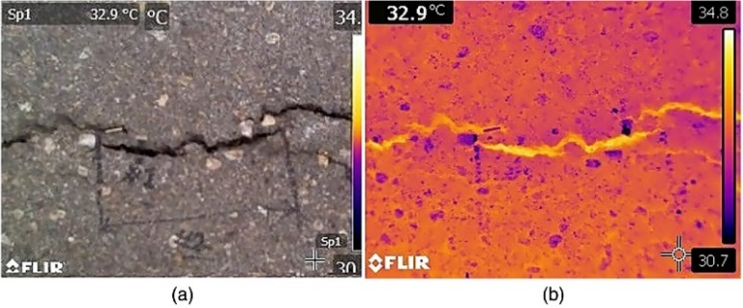
- Ultrasonic and Thermal Imaging: These non-destructive techniques detect Defects beneath surfaces but require specialized equipment.

- Image Processing-Based Detection: Methods such as edge detection, thresholding, and contour analysis identify Defects in images captured from cameras. They do not provide us the facility of live surveillance.
- Deep Learning-Based Approaches: CNNs (Convolutional Neural Networks) and AI models are trained on large datasets to detect Defects with higher accuracy.

2.2 Related Works
Several studies have proposed solutions for automated Defect detection:
- Defect Detection in Concrete Structures Using Image Processing
  - DOI: https://doi.org/10.1016/j.autcon.2020.103150
  - Used edge detection algorithms to segment Defects in concrete structures.
- Automated Defect Detection Using Deep Learning
  - DOI: https://doi.org/10.1109/TNNLS.2020.2987097
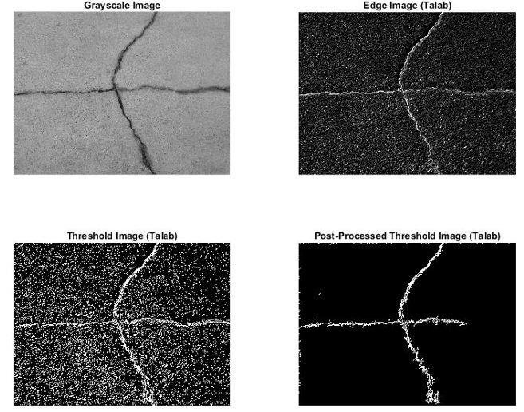
  - Trained a CNN model to classify Defect severity with high accuracy.
- Complex Artifact Shapes and Layered Structures
Wu et al. (2023) used acoustic emission sensors to monitor metal sculptures in real time, detecting Defects that formed beneath the surface. Similarly, Luo et al. (2023) used 3D laser scanning to create detailed digital models of artifacts, making it easier to spot Defects on complex shapes or under layers of paint.
- Real-time Monitoring
Zhao et al. (2023) developed a system that combined machine learning with real-time data from sensors to monitor ceramics. As Defects developed, the system tracked them over time and warned conservators when the Defects became critical.
2.3 Challenges in Automated Defect Detection
- Variability in Lighting Conditions: Shadows and reflections can affect detection accuracy.
- Noise in Images: Dust, dirt, and external factors may interfere with image processing.
- False Positives: Some textures or stains might be wrongly classified as Defects.
2.4 Motivation for Developing a Defect Detection Tool
- Automation & Efficiency: Eliminates manual labour and enables 24/7 monitoring (live surveillance).
- Cost-Effective: Reduces the need for frequent on-site inspections.
- Early Detection & Prevention: Identifies Defects before they become critical, reducing repair costs.
2.5 Potential Features of the Proposed Defect Detection Tool
- Live Monitoring: Uses a fixed camera (CCTV, drone, or mobile) to capture images at regular intervals.
- Real-Time Image Processing: Applies Structural Similarity Index (SSIM) and edge detection to identify Defects.
- Automated Alerts: Sends notifications if significant damage is detected.
- Data Logging & Report Generation: Maintains a record of detected Defects for future analysis.
- Cloud Integration & Remote Access: Allows stakeholders to monitor infrastructure remotely.
CHAPTER – 3: PROBLEM STATEMENT

- Structural integrity is crucial for civil infrastructure, heritage artifacts, and valuable objects, yet Defects and damages often go unnoticed until they pose a serious threat.
- Manual inspection methods are time-consuming, costly, and prone to human error. Traditional Defect detection techniques, which rely on periodic inspections, may fail to detect early-stage damage, leading to structural failures or irreversible degradation.
- Detecting Defects especially in museum artifacts under real-world conditions is a complex and sometimes unpredictable task. While modern technologies like machine learning, image processing, and sensors have made great strides in Defect detection, they still need to contend with the everyday realities of museum environments.
- These environments are not controlled laboratories but dynamic spaces where lighting, temperature, and humidity vary throughout the day, where artifacts are made of a range of materials, and where shapes and surface details can be intricate and complex.
To ensure that artifacts are protected, Defect detection systems need to be flexible and robust enough to handle these challenges.

CHAPTER – 4: PROPOSED SOLUTION

The proposed system is an automated Defect detection tool that continuously monitors an object using a fixed camera. It captures images in real time and compares them with previous images to detect Defects or damages. This system is useful for museums, civil structures (bridges, dams), and valuable artifacts that require 24/7 monitoring.

4.1 Key Features & Functionalities

4.1.1. Real – Time Image Capture
- The system work in real time and detects if there any changes occurred.
- The first image serves as the reference, and upon selecting the region of interest this will compare it with further video feed.

4.1.2. Multi Camera Monitoring
- Multiple client systems stream live video over a local network to a centralized server.
- If significant differences (Defects or damage) are found, the system highlights the affected area using a red bounding box.
- A thresholding technique ensures only major changes are detected, reducing false positives.

4.1.3. Application in Various Domains
- Museum & Artifacts: Protects valuable objects by detecting small Defects or deterioration over time.
- Civil Infrastructure: Helps in early detection of Defects in bridges, roads, and dams, reducing maintenance costs.
- Industrial Monitoring: Used in factories and pipelines to detect structural weaknesses.

4.1.4. Data Logging & Analysis
- The initial reference image and the defect snapshot are automatically captured and stored by each client for later examination and documentation.
- It can also show the defected and initial image upon clicking the small feeds in the small feed in sidebar.

4.1.5. User-Friendly Configuration
- The user has to select the region first then the system will do its work automatically.
- When defect is detected then in sidebar the video feed pops up a red dot.
4.1.5. Centralized Web-Based Dashboard:
- A Flask server aggregates all video streams and exposes a browser-based interface (index.html), enabling remote monitoring without manual file handling or local display requirements.

CHAPTER – 5: EXPERIMENTAL SETUP

5.1 Software Requirements:
Here’s a concise list of software requirements — one point for each:
- Operating System: Windows / Linux / macOS
- Programming Language: Python 3.8+
- Libraries: OpenCV, NumPy, Flask
- Web Framework: Flask (for HTTP streaming and dashboard integration)
- Web Technologies: HTML5, CSS3, JavaScript (for the dashboard UI)
- HTTP Streaming Protocol: MJPEG / HTTP Live Streaming (HLS)
- Browser Compatibility: Chrome / Edge / Firefox (for live visualization)
- IDE / Code Editor: VS Code / PyCharm
- Version Control: Git & GitHub (for project tracking and collaboration)
5.2 Installation & Setup:
Step 1: Install Required Libraries
Run the following command to install dependencies:

Step 2: Setup Project Folder Structure
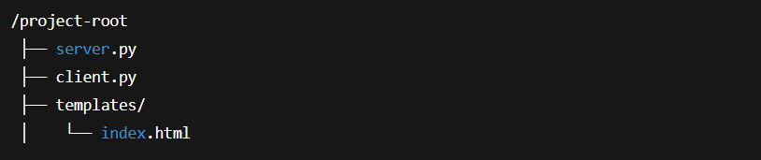
Step 3: Configure the Client Systems
On each system with a webcam:
- Copy client.py to that system
- Run the script
Step 4: On the first run, a window will open to select ROI manually
  - Drag to select the defect monitoring region
  - Press Enter to lock ROI

The client starts streaming on
Step 5: Configure the Server Machine
- Open server.py and edit the STREAM_URLS list with the IPs of all client systems
Step 6: Then run the server
The dashboard will be available at:
Step – 7: Access the Multi-Camera Dashboard
Open any browser on the same network and visit:
Step – 8: Defect Image Capture (Automatic)
When a defect/change is detected by a client:
- The bounding box appears on the feed
- Initial ROI and defect images (initial.jpg and defect.jpg) are stored on that client
- Server can fetch them using /defect_images/<cam_id>
5.3 Experiment Procedure
Step 1 – Setup the Camera Clients
- Place each client system in front of the object or surface to be monitored.
- Ensure stable lighting and fixed camera position to avoid false detections.
Step 2 – Start the Client Script and Select ROI
- Run client.py on each client machine. On the first launch, the script will display the live camera frame and prompt the user to select a Region of Interest (ROI). The user selects the ROI manually, which is then stored as the reference region for further comparison.
Step 3 – Start the Central Server
- On the main monitoring system, run server.py after updating the STREAM_URLS list with the IP addresses of all running clients. The server automatically connects to each client and prepares the live dashboard.

Step 4 – Open the Monitoring Dashboard
- Access the dashboard from any browser using the server's IP and port (e.g., http://<server-ip>:8000). All live camera feeds will be visible in a grid layout along with timestamps and preview thumbnails.
Step 5 – Introduce Defects or Simulate Changes
- Create or simulate a defect in the monitored region (e.g., drawing a mark, placing an object, or altering the surface). The client processes each incoming frame, detects changes within the ROI, draws bounding boxes over defect regions, and updates the detection status.
Step 6 — Capture and Analyze Defect Images
- When a defect is detected, the client automatically saves the initial reference image and the defect image. The server can fetch these images through its /defect_images API and present them for comparison and documentation.
Step 7 — Observe and Record the Results
- Monitor the detection behavior through the web UI. Verify whether bounding boxes appear correctly on defective regions and check the stored images for validation. Note detection accuracy, false positives, and response delay if any.
Step 8 — Repeat and Evaluate
- Repeat the process with different lighting, surfaces, or defect types to test reliability. Fine-tune the ROI or adjust the environment to improve detection results.

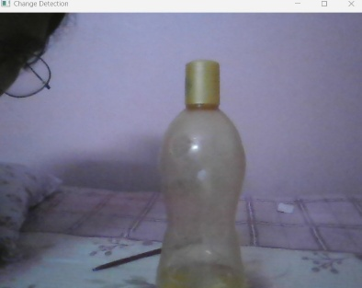
Fig: Original image(ROI)
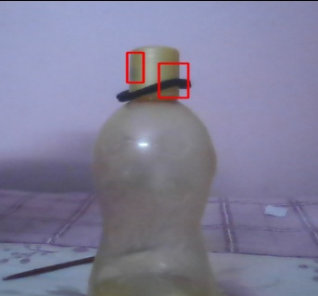
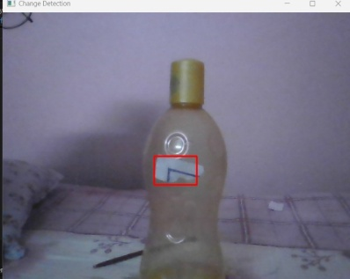
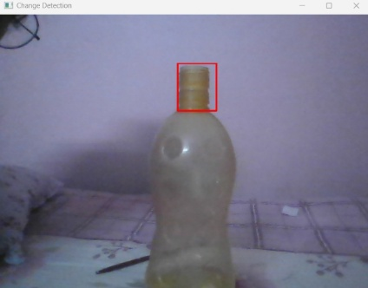

Fig: Defected Images(captured during live experimentation)

WORKING METHODOLOGY

1. User Interface (Frontend — Central Server Dashboard)
The system provides a web-based dashboard where users can:
- View live video streams from multiple client cameras
- Monitor real-time defect highlighting on each feed
- Preview saved initial and defect images in the sidebar
- Check camera status indicators and timestamps dynamically
2. Client Initialization (Local Camera Node Setup):
- Each client system runs client.py with an attached camera
- On startup, the user selects an ROI (Region of Interest) manually
- The selected ROI is saved as the reference baseline image
- The client begins processing live frames continuously
3. Real-Time Processing at Client (Backend Detection Logic):
- The client extracts the ROI from every new frame
- Converts ROI to LAB color space and applies Gaussian blur
- Compares with reference ROI to detect intensity changes
- Draws red bounding boxes when a defect/change is found
- Saves initial.jpg and defect.jpg when triggered
- Exposes HTTP endpoints /video, /status, and /defect_image
4. Server-Side Aggregation (Central Flask Application):
- server.py maintains the IP list of all active clients
- Fetches /video streams and proxies them to the UI
- Periodically calls /status to detect defect triggers
- Requests defect images when needed using /defect_images/<id>
- Renders all feeds and previews via index.html

5. View Detection Results (Web Dashboard Monitoring):
- All camera feeds are displayed simultaneously in a grid layout
- Defects appear with red bounding boxes in real time
- Sidebar shows saved initial and defect ROI snapshots
- Timestamps auto-refresh without reloading the page
6. Stop, Store & Review Evidence:
- Defect images remain stored locally on their respective clients
- The server can recall them anytime using API endpoints
- Users can later analyze stored images for documentation or reporting
- Monitoring continues continuously unless manually terminated
You can review the saved images upon clicking on the sidebar small feed.
5.4 Interface Architecture and Component Description :
1.Initialization: When the program starts, the system initializes the camera feeds, loads the reference image, sets up ROI (Region of Interest) selection .
2.Main Interface: The dashboard displays multiple camera feeds in a grid layout. Each feed is continuously analyzed for defects using OpenCV. If a defect is detected, it is highlighted with a red bounding box around the affected area.
3.Sidebar Pannel :The sidebar lists all camera feeds or machine stations. When a defect is detected in any feed, a red dot appears beside that camera’s label, indicating the location of the issue.
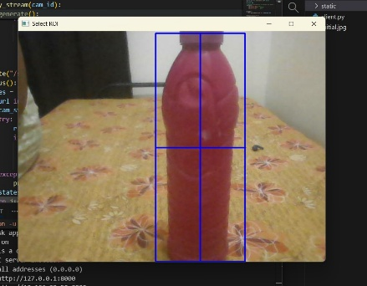
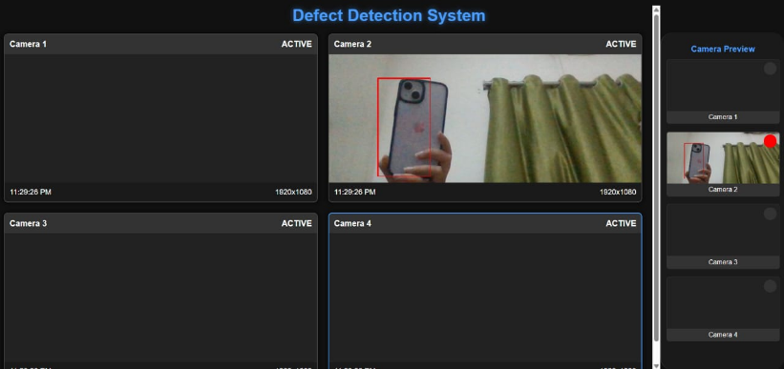
4.Defect Analysis Section (pop up): By clicking a specific sidebar item, the system displays a detailed comparison between the initial reference image and the current defective image, allowing users to visually assess and verify the defect.
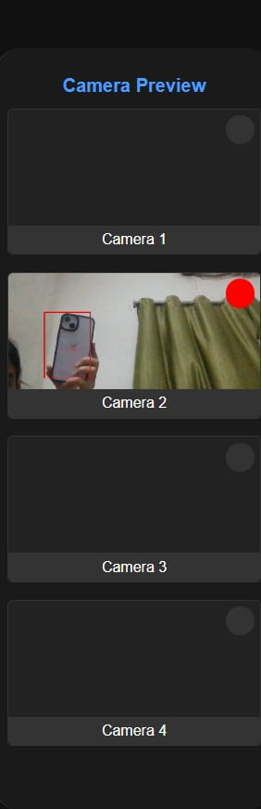
1. 2.
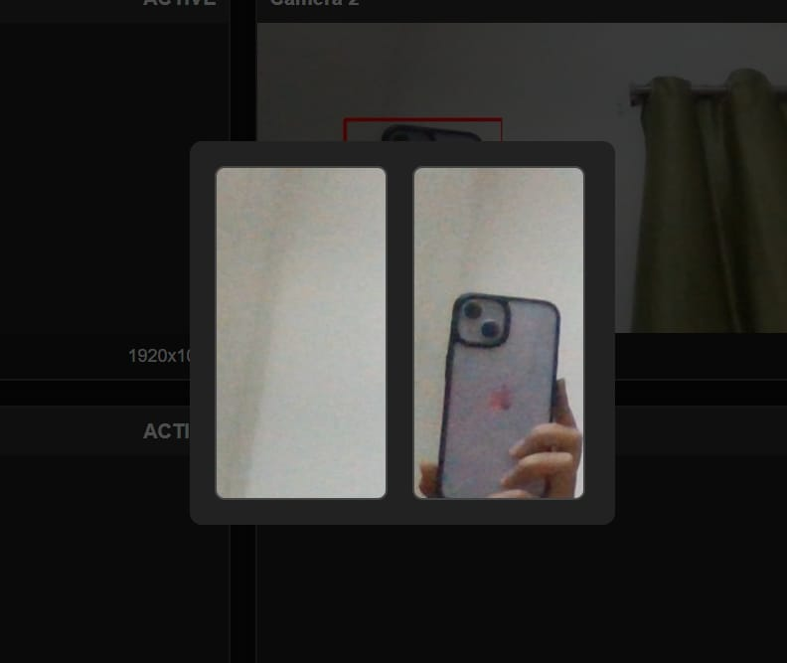

3. 4.
CHAPTER – 6: RESULT ANALYSIS
6.1. Image Capture & Preprocessing
The system captures a reference ROI image once during initialization when the user manually selects the monitoring region. The client then continuously reads live frames from the camera, extracts the same ROI, converts it to LAB color space, and applies Gaussian blur to reduce noise before comparison.
Success Criteria:
- The ROI is selected and stored without failure during initialization
- Camera feed is read continuously without frame drops
- Preprocessing (LAB conversion + blur) is applied without latency
Possible Issues:
- Camera not detected or blocked → ROI cannot be initialized
- Poor lighting → increases noise and reduces change detection accuracy
- Incorrect ROI selection → irrelevant area monitored
6.2. Defect Detection & Image Processing
For every frame, the system compares the processed ROI against the stored reference. If significant pixel-level change is detected, bounding boxes are drawn around the affected region. The initial ROI and defect ROI are saved locally (initial.jpg, defect.jpg) when triggered.
Success Criteria:
- Defective/change regions are highlighted with red bounding boxes
- Defect images are saved correctly upon detection
- Change flag (change_detected) is updated reliably
Possible Issues:
- Small or gradual changes may go undetected
- False positives due to shadows or reflections
- Multiple minor contours may trigger unnecessary defect flags
- Reference image may become outdated if surface permanently changes
6.3. Log & API Response Analysis
The server periodically calls each client’s /status, /video, and /defect_image endpoints to collect real-time feed and detection results. The dashboard accurately reflects the defect status for each camera in the UI.
Success Criteria:
- /status returns correct JSON change flag from each client
- /defect_images/<id> returns valid initial & defect image URLs
- Server successfully proxies all video streams without timeout
Possible Issues:
- 500 Internal Server Error → due to client camera failure or timeout
- Empty defect image response → if no defect captured yet
- Server cannot reach client IP → offline or wrong IP in STREAM_URLS
- High latency/packet loss → delayed or frozen feeds
CHAPTER – 7: FUTURE SCOPE
Although the current implementation successfully performs real-time defect detection using multiple distributed cameras and a centralized dashboard, several enhancements can be incorporated to improve its accuracy, scalability, and industrial applicability in the future:
- AI-Based Defect Classification: Instead of simple color difference comparison, modern deep learning models such as YOLO, Faster R-CNN or MobileNet can be integrated to classify types of defects (crack, corrosion, stain, dent etc.) and reduce false alarms.
- Adaptive Reference Updating: The system can be improved by automatically updating the baseline image after confirmed inspection to avoid repeated triggers from the same permanent defect.
- Hardware Alarm and Alert System: The system can be extended to trigger buzzer alerts, SMS notifications, or email alerts whenever a defect is detected without requiring manual monitoring.
- Cloud Integration for Remote Access: Captured defect images and status logs can be uploaded to a secure cloud database, enabling remote supervision from anywhere and long-term storage without local memory constraints.
- Mobile and IoT Integration: A mobile app or lightweight IoT interface can be developed for real-time remote monitoring on smartphones and integration with enterprise monitoring frameworks.
- Multi-ROI and Multi-Object Tracking: Future versions can allow selection of multiple ROIs per camera and track multiple surfaces or objects simultaneously from the same feed.
- Edge Deployment on Raspberry Pi / Jetson Nano: To reduce server dependency, client nodes can be implemented on edge devices for cost-effective industrial deployment with offline capability.
These future enhancements would transform the current prototype into a robust, intelligent, and scalable defect surveillance platform suitable for real-world industrial, civil, and heritage monitoring applications.

CHAPTER – 8: CONCLUSION

This project demonstrates the development of a practical and lightweight multi-camera defect detection system capable of performing continuous visual inspection using real-time video streams. By integrating Flask for distributed service orchestration and OpenCV for live image acquisition and processing, the system efficiently aggregates multiple client camera feeds into a unified web-based dashboard. This centralized interface not only simplifies monitoring by displaying all streams simultaneously but also highlights detected defect regions within the feed, thereby improving visibility and decision-making during inspection.
The system currently operates using a Region-of-Interest (ROI) based detection mechanism, which proves sufficient for many industrial and surveillance applications where specific areas need continuous observation. This approach enables low-latency detection without the overhead of advanced computation, making the solution scalable for deployment in cost-sensitive or resource-limited environments. It also provides automated capture and storage of defect images, ensuring visual evidence is retained for further analysis.
Despite its effectiveness, the prototype reveals certain limitations. Manual ROI selection can introduce subjectivity, and performance is dependent on stable lighting and network availability. Additionally, the existing implementation lacks built-in security controls and intelligent classification of defect types. These limitations present opportunities for enhancement in future iterations.
Future improvements may include adaptive ROI mechanisms, cloud or mobile integration for remote access, secure authentication for networked nodes, and the incorporation of deep learning models for automatic defect classification without manual intervention. With further refinement and optimization, this system can evolve into a robust, industry-grade solution for autonomous defect surveillance, predictive maintenance, and safety-critical monitoring across civil, industrial, and heritage infrastructures.

BIBLIOGRAPHY

[1] | Arun Mohan, Sumathi Poobal  Crack detection using image processing: A critical review and analysis  Alexandria Engineering Journal, June 2018  View Article↗
[2] | R.S. Adhikari, O. Moselhi, A. Bagchi  Image-based retrieval of concrete crack properties for bridge inspection  Automation in Construction, April 2014  Google Scholar↗
[3] | Zhu Qingbo  Pavement Crack Detection Algorithm Based on Image Processing Analysis  8th IHMSC, August 2016  Google Scholar↗
[4] | Zheng, Paul  Crack Detection and Measurement Utilizing Image-Based Reconstruction  Google Scholar↗
[5] | Łukasz Bratasz, Kiraz Goze Akoglu, Patrick Kékichef  Fracture saturation in paintings makes them less vulnerable to environmental variations in museums  View Article↗
[6] | Y. Fujita, Y. Mitani, Y. Hamamoto  A Method for Crack Detection on a Concrete Structure  18th ICPR’06, August 2006  View Article↗
[7] | Ikhlas Abdel-Qader, P.E., Osama Abudayyeh, P.E., M. ASCE, Michael E. Kelly  Analysis of Edge-Detection Techniques for Crack Identification in Bridges  Journal of Computing in Civil Engineering, Sep 2003  View Article↗
[8] | Vikram K. Kinra, Atul S. Ganpatye & Konstantin Maslov  Ultrasonic Ply-by-Ply Detection of Matrix Cracks in Laminated Composites  Journal of Nondestructive Evaluation, May 2006  Google Scholar↗
[9] | Mohammad R. Jahanshahi, Sami F. Masri  Adaptive vision-based crack detection using 3D scene reconstruction for condition assessment of structures  Automation in Construction, March 2012  Google Scholar↗
[10] | S.G. Lee, Y. Mao, A.M. Gokhale, J. Harris, M.F. Horstemeyer  Application of digital image processing for automatic detection and characterization of cracked constituent particles/inclusions in wrought aluminum alloys  Materials Characterization, Sep 2009  Google Scholar↗
[11] | Vimal Babu, Sandeep Kumar  OpenCV libraries for Benzene Image Processing Applications using Python Programming  International Journal of Recent Technology and Engineering (IJRTE), Nov 2019  View Article↗
[12] | Stéfan van der Walt​, Johannes L. Schönberger, Juan Nunez-Iglesias, François Boulogne, Joshua D. Warner, Neil Yager, Emmanuelle Gouillart, Tony Yu  scikit-image: image processing in Python  PeerJ , June 2014  View Article↗

